Dear Member

We have very exciting news to share with you, news that will make your credit union stronger and better in virtually every way and will help to even further solidify your financial future.

After months of discussion and analysis, USA Credit Union has made the decision to merge with T&C Credit Union of Bloomfield Hills. Our new organization will be called Genisys Credit Union, but more about that later.

First the question that’s probably uppermost in your mind, “Why are we merging and what’s in it for me as a member?” The answer is that our merged credit union will be a much more substantial player in the credit union industry. We will be able to access funds more easily and less expensively. This translates into improved rates and higher dividends for you. We will have more branches in our Michigan community, but more important for you, we’ll offer more services, more expertise, more convenience and more opportunities to add to member benefits in the future. Most importantly, we’ll still be your credit union and your interests, as always, will be our Number One priority.

Combining two healthy credit unions will make us stronger and better in every respect. And because of the existing similarities and shared values between USA and
T&C, we believe this particular consolidation will be better than most. We are taking two very strong institutions and merging them to make one even stronger one. The newly merged company will be among the top 100 credit unions nationwide in terms of assets ($1.2 billion). That gives us more clout and more borrowing power than we ever could have had individually, and this again results in better opportunities for each of our members.

Genisys comes straight out of our roots – “Gen” from the General Motors members who started T&C and “isys” from the Unisys members who form the foundation of USA. We are not forgetting who we are or where we came from. We are Proud of our Past and Passionate about Our Future. Both credit unions have grown from their original roots to serving households and businesses of large communities. We are not forgetting that our members are the reason we exist and we are not in any way forsaking the community values that have made our company what it is today. Still, we look forward to taking your credit union to the next level – in the credit union world and in your world.

Over the next few months we’ll be providing you with added information on this pending merger and what it means to you. We think you’ll like what you see.

As President and CEO of your credit union, I am extremely excited about this new opportunity. Dianne Addington, the CEO of T&C, will be assuming the role of CEO in the new Genisys Credit Union. I will continue to serve as President of the new entity until my planned retirement date early next year. I am confident that the combined management teams of the two credit unions will lead Genisys to providing even greater value to our members.

Thank you for your membership and for your confidence in USA Credit Union. Please call 248-322-9800 or 800-521-8440 and ask to speak to a member of the merger team if you have any questions or concerns. In the meantime, we will continue “business as usual” and, as always, will do everything in our power to provide you world class service and to earn your continued trust now and in the future.

Sincerely,

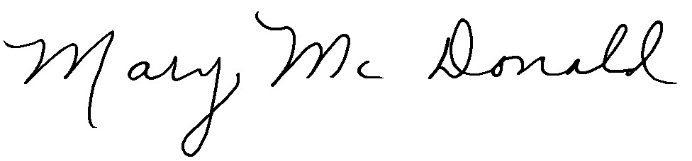
Mary McDonald
President & CEO

